Data Visualization Project
2025-26
VIT BHOPAL

“Data Visualization Project for
Online Pet Food Ordering System
using Python and MySql."

SUBMITTED BY:

SARAH AHMED
B.TECT CSE(CORE)

CONTENTS

- Front End & Back End
- User working Analysis
- E R Diagram
- MySQL commands
- Python Coding
10. Bibliography

FRONTEND

The project uses python as its FRONTEND, that is it is the part where user interact.
The front end basically includes input facilities through which the user interact. Apart from the user interaction, the front end also contains database objects that form a layer between the user and BACKEND.
BACKEND
MySQL is used as a BACKEND. It handles all database accesses through one or more servers. A Server is a special computer that is responsible for processing requests send to it. It processes all the data and query passed to it and sends result back to the front end where it is displayed to the user.

USER WORKING ANALYSIS
This ER model is for Online Pet Food Ordering System platform which will allow the customers to register feeding their details once. Using mobile number and Email to identify customer uniquely. Each customer can have his or her choice for different types of order and each order can accommodate many order according to his specialty. Number of Pet Food store are registered on our platform and each store can list number of types of Pet Food like Dog Food, Cat Food, Bird Food, Fish Food etc. Customer can choose from these Pet Food according to their need and can order.
Customer has to provide his details and using mobile number and password can login into his account. Same way Pet Food Ordering System can login with his id and password every time and can check his order, Also feedback can be registered by anyone who is our customer and customer can also RATE the prediction of the Store.
Additionally, users manage their profiles, payment modes and view order history for easy recording. Customer support is available for any issues or inquiries, ensuring a smooth and satisfactory
Experience from start to finish. This structural workflow enhances convenience and efficiency, making online pet food ordering user friendly.
Delivery man can select their orders according to the given road route allotted to them. They can also select or pick the given orders according to the time when they are free. Moreover registered pet food shops can select which all orders they can take according to their closing and opening time, brand of food out of stock or minimum order cost.

ER DIAGRAM

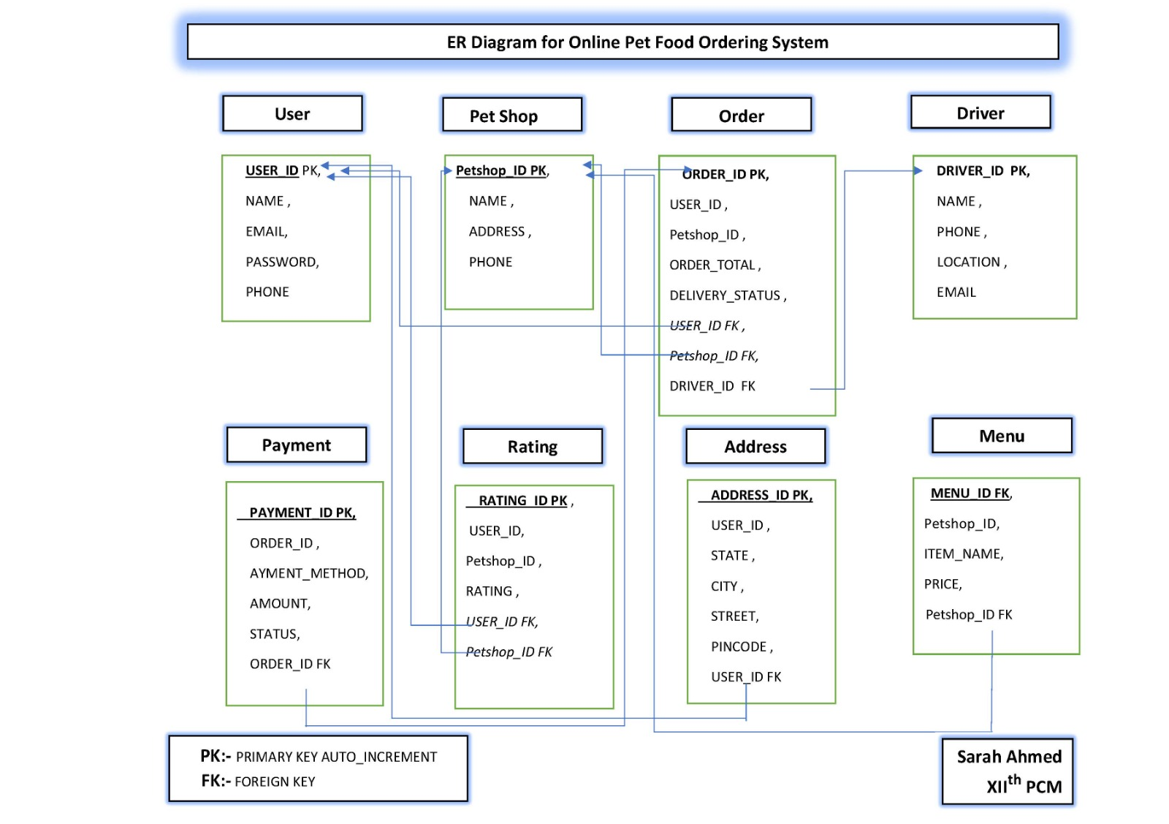

MY-SQL Commands

Create users Table

mysql> CREATE TABLE Users (
-> user_id INT PRIMARY KEY AUTO_INCREMENT,
-> name VARCHAR(255) NOT NULL,
-> email VARCHAR(255) NOT NULL,
-> password VARCHAR(255) NOT NULL,
-> phone VARCHAR(20) NOT NULL,
-> UNIQUE (email)
-> );
Query OK, 0 rows affected (0.04 sec)

Insert Date into the users Table
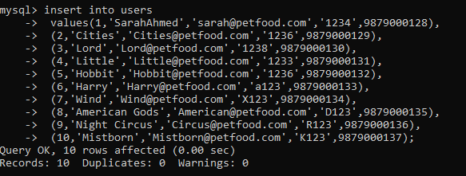
Fetch Data from users table

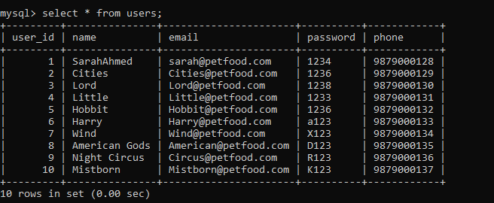

Create pet shop Table

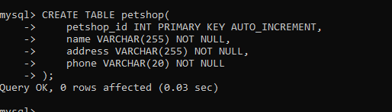
Insert Data into the pet shop TABLE

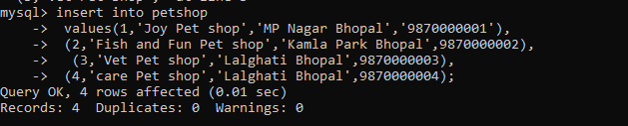
Fetch Data from pet shop table

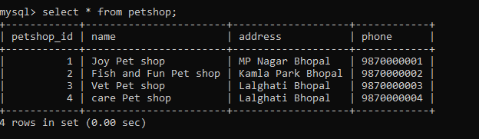

Create Order Table

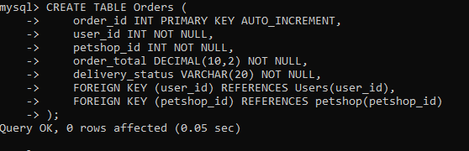

Insert Data into the Order TABLE

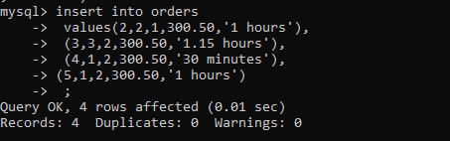

Fetch Data from orders table

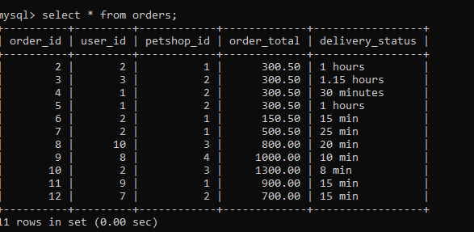

Create Driver Table

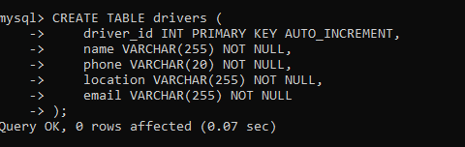

Insert Data into the Drivers TABLE

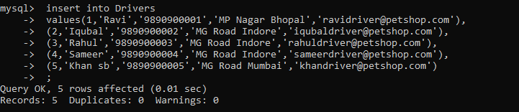

Fetch Data from Drivers table

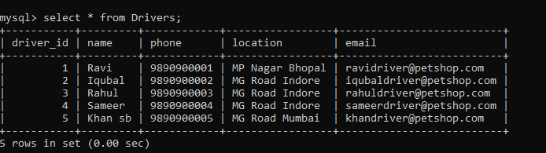

Create payment Table

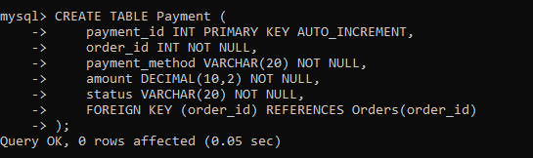

Insert Data into the payment TABLE

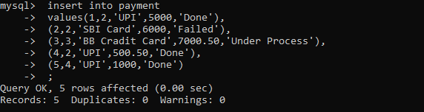

Fetch Data from Payment table

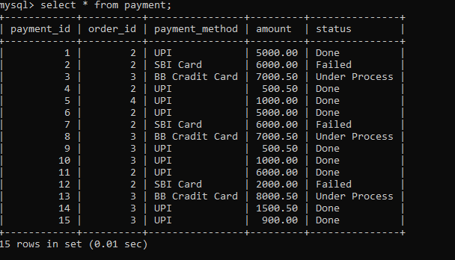
Create Rating Table

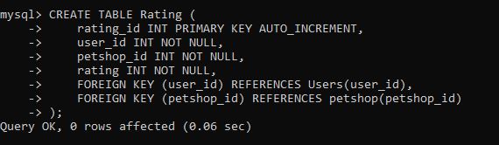

Insert Data into the Rating TABLE

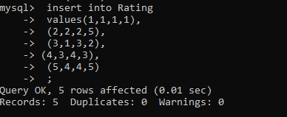

Fetch Data from rating table

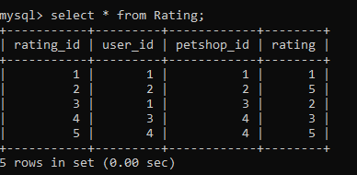

Create Address Table

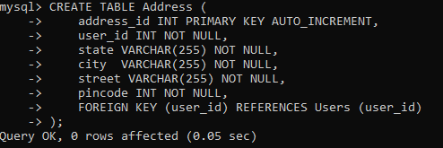

Insert Data into the address TABLE

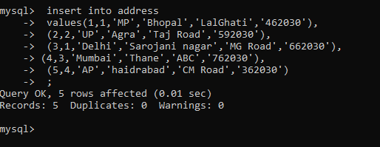

Fetch Data from address table
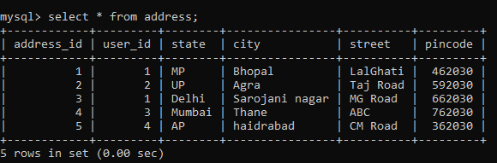

Join to tables with group by clause

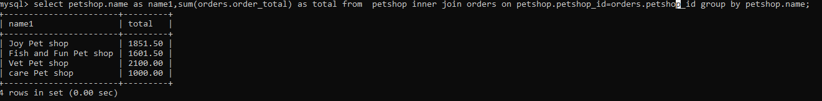

Python Commands

Graph to analysis the purchase of each petshop

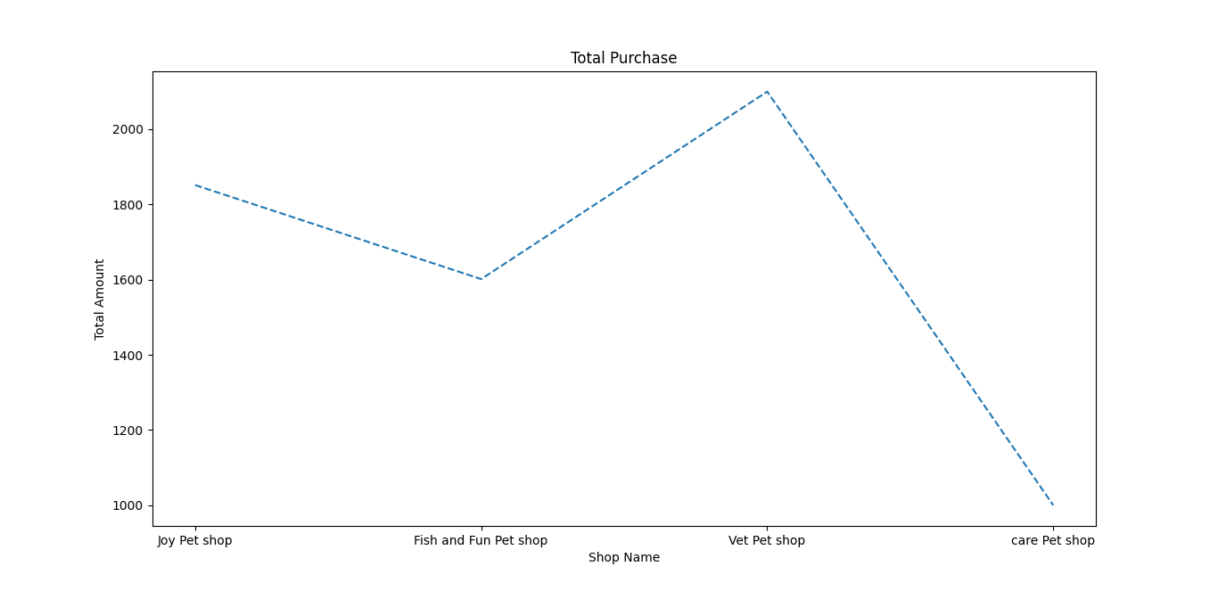
import numpy as np
import mysql.connector as m
import matplotlib.pyplot as plt

#Fetching data from mysql.
Mydb=m.connect(host='localhost',user='root',password='sa123',database='ofos')

mycursor=Mydb.cursor()

mycursor.execute('select petshop.name as name1,sum(orders.order_total) as total from petshop inner join orders on petshop.petshop_id=orders.petshop_id group by petshop.name')

result=mycursor.fetchall

name1=[]
total=[]

for i in mycursor:
name1.append(i[0])
total .append(i[1])
print("Name of the Shop",name1)
print("Total Purchase ",total )

plt.xlabel('Shop Name')
plt.ylabel('Total Amount')
plt.title('Total Purchase')
plt.plot(name1,total,linestyle='dashed',)
plt.show()

Bar Graph on shop Rating
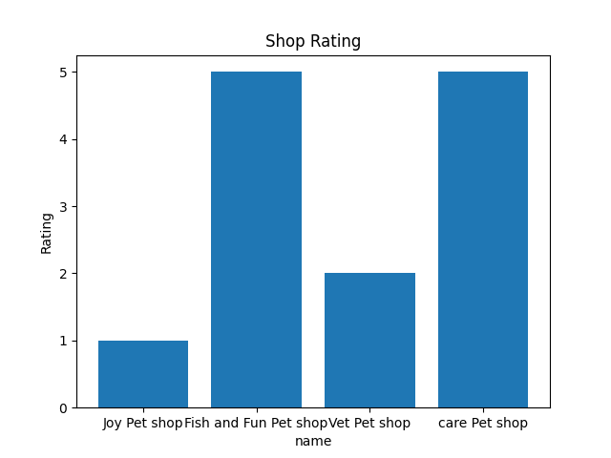

import numpy as np
import mysql.connector as m
import matplotlib.pyplot as plt

#Fetching data from mysql.
Mydb=m.connect(host='localhost',user='root',password='sa123',database='ofos')

mycursor=Mydb.cursor()

mycursor.execute('select petshop.name as name,rating.rating as rating from petshop inner join rating on petshop.petshop_id=rating.petshop_id')

result=mycursor.fetchall

name=[]
rating=[]

for i in mycursor:
name.append(i[0])
rating.append(i[1])
print("Name of the Shop",name)
print("Shop Rating",rating)

plt.xlabel('name')
plt.ylabel('Rating')
plt.title('Shop Rating')
plt.bar (name,rating)
plt.show()

Line graph on Menu Detail
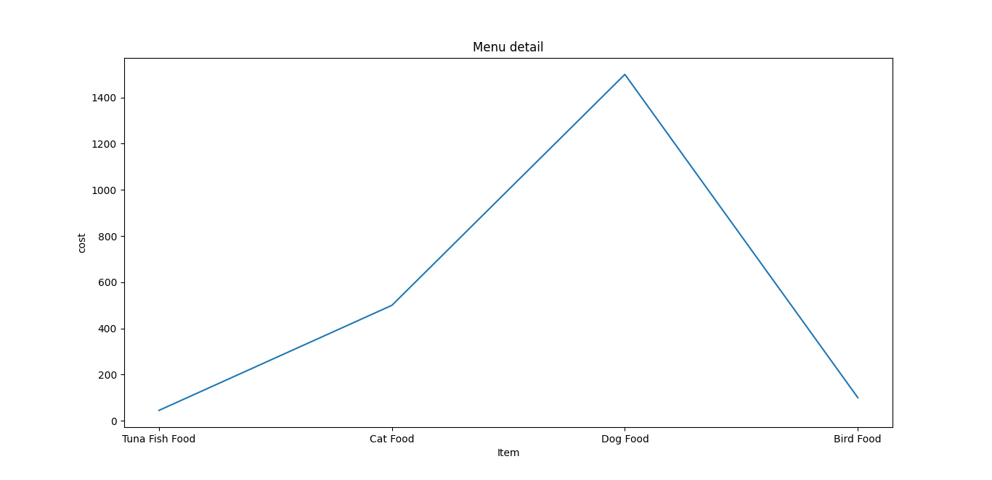

import numpy as np
import mysql.connector as m
import matplotlib.pyplot as plt

#Fetching data from mysql.
Mydb=m.connect(host='localhost',user='root',password='sa123',database='ofos')

mycursor=Mydb.cursor()

mycursor.execute('select item_name , price FROM menu')

result=mycursor.fetchall

item_name=[]
price=[]

for i in mycursor:
item_name.append(i[0])
price.append(i[1])
print("item",item_name)
print("price",price)

plt.xlabel('Item')
plt.ylabel('cost')
plt.title('Menu detail')
plt.plot (item_name,price)
plt.show()

Scatter Graph on mode of payment
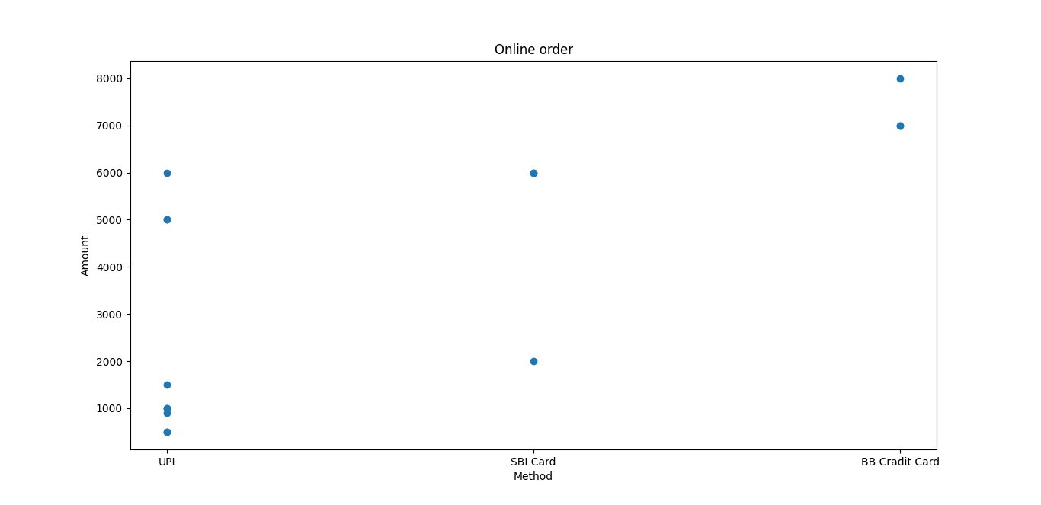
import numpy as np
import mysql.connector as m
import matplotlib.pyplot as plt

#Fetching data from mysql.
Mydb=m.connect(host='localhost',user='root',password='sa123',database='ofos')

mycursor=Mydb.cursor()

mycursor.execute('select payment_method ,amount FROM payment')

result=mycursor.fetchall

payment_method=[]
amount=[]

for i in mycursor:
payment_method.append(i[0])
amount.append(i[1])
print("Method",payment_method)
print("Amount",amount)

plt.xlabel('Method')
plt.ylabel('Amount')
plt.title('Online order')
plt.scatter (payment_method,amount)
plt.show()

BIBLIOGRAPHY

- Sumita Arora – Informatics Practices Class XII.

- www.geeksforgeeks.org

- www.youtube.com

- www.stackoverflow.com

SUBMITTED BY:

SARAH AHMED
BTECH CSE(CORE)
25BCE11375

